Islamic (Hijri) Calendar
# Source: AI Source: Provided by: [Data Path: Persons Table -> ID Column: 1, Name_En Column: Motasem Essam] -> From: [ChatGPT] on [7/17/2026]
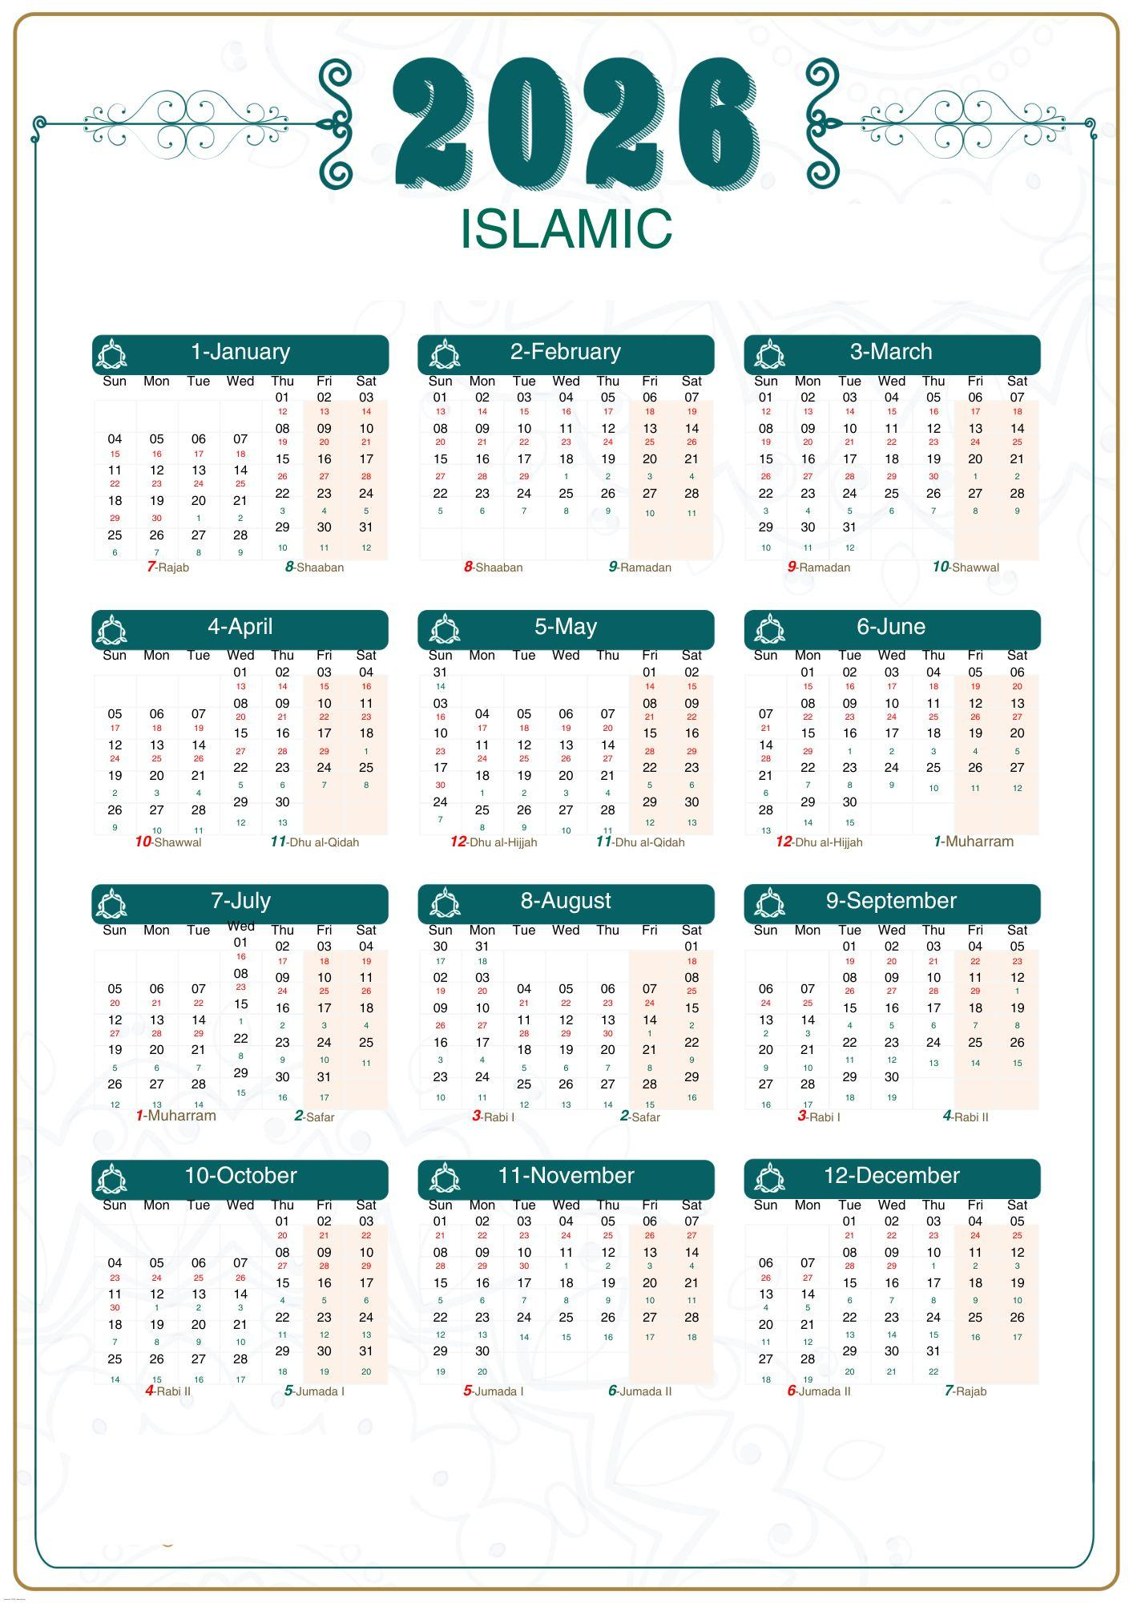
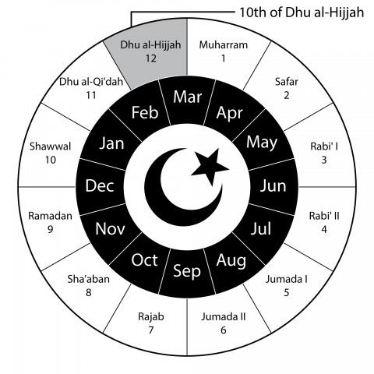
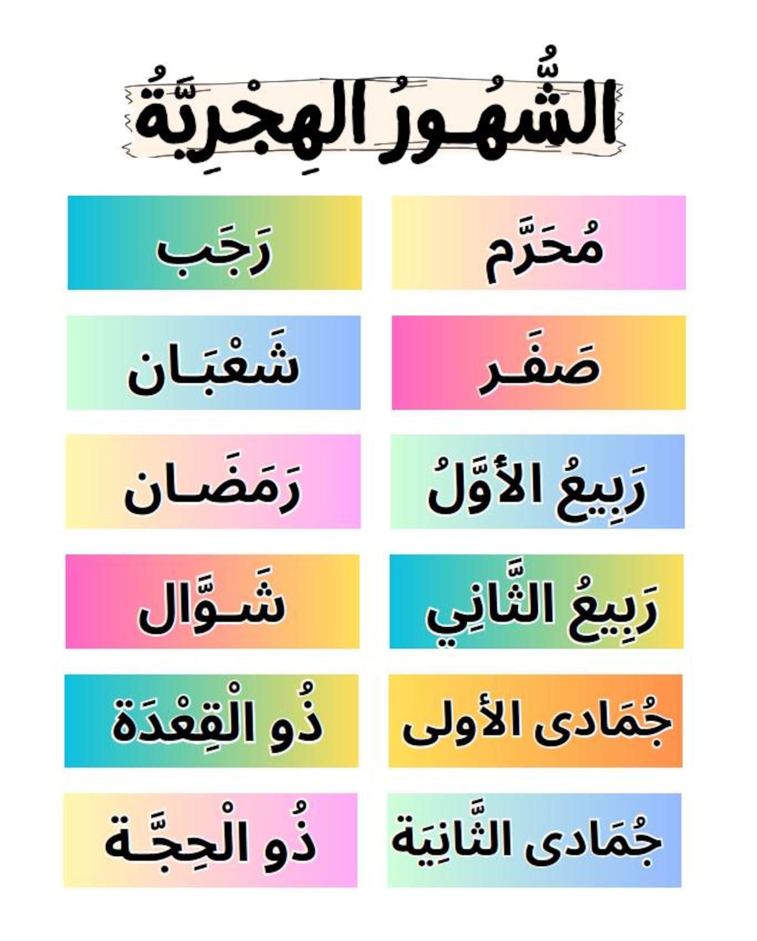
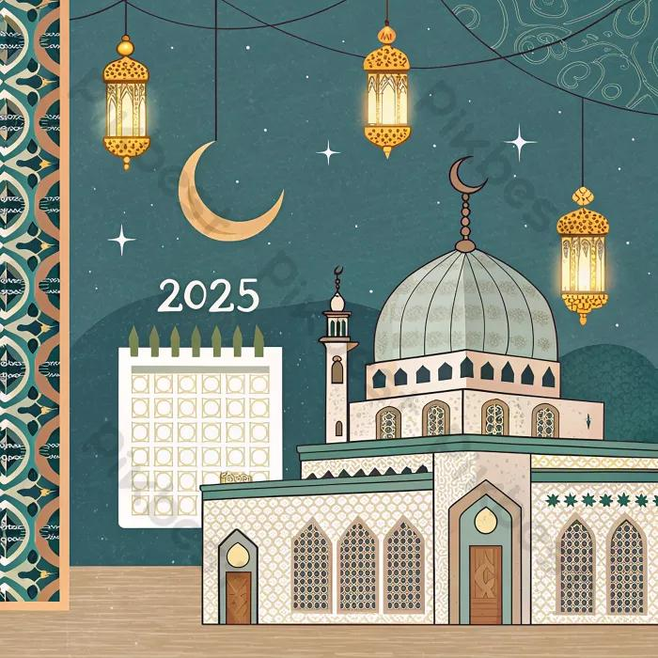
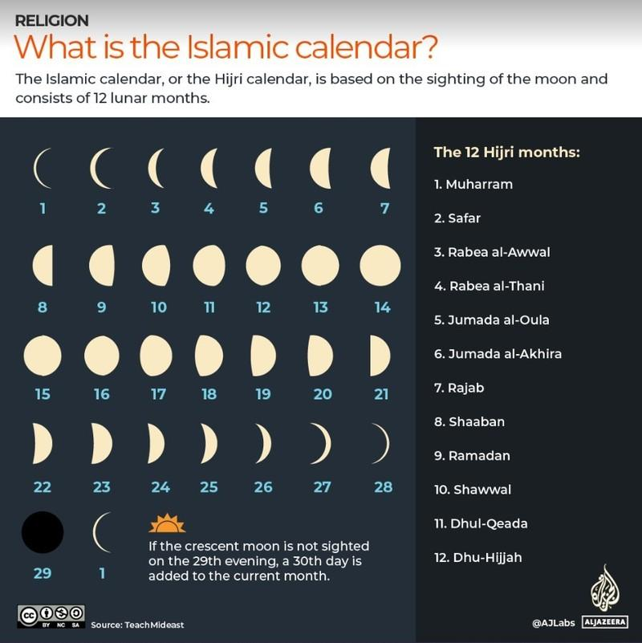
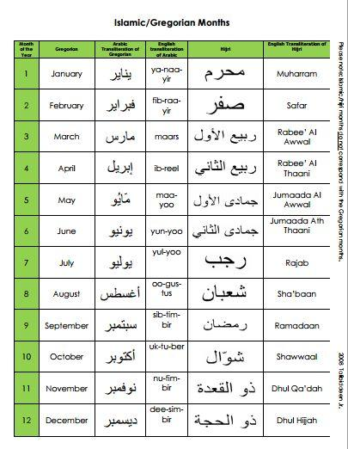
The Islamic (Hijri) Calendar is a lunar calendar used by Muslims around the world to determine religious dates, festivals, and observances. Unlike the Gregorian Calendar, which is based on the Earth's orbit around the Sun, the Hijri Calendar is based on the phases of the Moon.
The calendar begins with the Hijrah (migration) of the Prophet Muhammad from Mecca to Medina in 622 CE, which marks the start of the Islamic era.

Definition
# Source: AI Source: Provided by: [Data Path: Persons Table -> ID Column: 1, Name_En Column: Motasem Essam] -> From: [ChatGPT] on [7/17/2026]
The Islamic (Hijri) Calendar is a lunar calendar consisting of 12 lunar months, used primarily to determine Islamic religious events and dates.

Purpose
# Source: AI Source: Provided by: [Data Path: Persons Table -> ID Column: 1, Name_En Column: Motasem Essam] -> From: [ChatGPT] on [7/17/2026]
The Hijri Calendar is used to:
- Determine the beginning and end of Ramadan.
- Schedule the Hajj pilgrimage.
- Identify Islamic holidays.
- Record religious dates.
- Organize religious events.
- Mark Islamic years.

History
# Source: AI Source: Provided by: [Data Path: Persons Table -> ID Column: 1, Name_En Column: Motasem Essam] -> From: [ChatGPT] on [7/17/2026]
Starting Event
The calendar begins with the:
- Hijrah (Migration)
This refers to the migration of Prophet Muhammad from:
- Mecca → Medina
Beginning of the Islamic Era
- 1 AH (Anno Hegirae)
Equivalent approximately to:
- 622 CE

Type of Calendar
# Source: AI Source: Provided by: [Data Path: Persons Table -> ID Column: 1, Name_En Column: Motasem Essam] -> From: [ChatGPT] on [7/17/2026]
The Islamic Calendar is a:
- Lunar Calendar
It is based on:
- The Moon's phases.

Structure of the Hijri Calendar
# Source: AI Source: Provided by: [Data Path: Persons Table -> ID Column: 1, Name_En Column: Motasem Essam] -> From: [ChatGPT] on [7/17/2026]
The Islamic Calendar contains:
- 12 lunar months
- 354 or 355 days per year
Each month begins with the sighting (or astronomical calculation, depending on local practice) of the new crescent moon.

Months of the Hijri Calendar
# Source: AI Source: Provided by: [Data Path: Persons Table -> ID Column: 1, Name_En Column: Motasem Essam] -> From: [ChatGPT] on [7/17/2026]
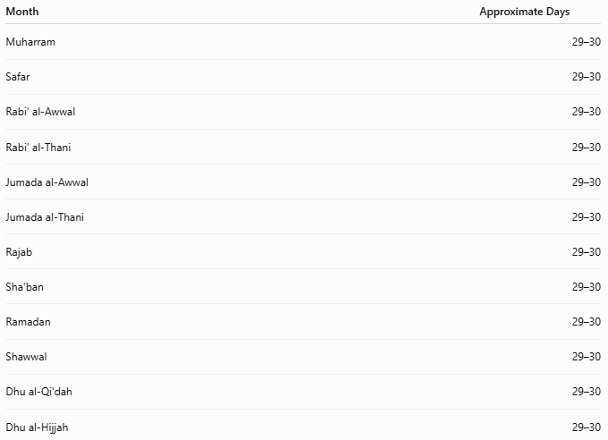
Month | Approximate Days
Muharram | 29–30
Safar | 29–30
Rabi' al-Awwal | 29–30
Rabi' al-Thani | 29–30
Jumada al-Awwal | 29–30
Jumada al-Thani | 29–30
Rajab | 29–30
Sha'ban | 29–30
Ramadan | 29–30
Shawwal | 29–30
Dhu al-Qi'dah | 29–30
Dhu al-Hijjah | 29–30

Length of the Year
# Source: AI Source: Provided by: [Data Path: Persons Table -> ID Column: 1, Name_En Column: Motasem Essam] -> From: [ChatGPT] on [7/17/2026]
A Hijri year contains approximately:
- 354 days (common year)
- 355 days (leap year)
Average length:
$$\boxed{354.37\text{ days}}$$
This is about 11 days shorter than the Gregorian year.

Leap Year
# Source: AI Source: Provided by: [Data Path: Persons Table -> ID Column: 1, Name_En Column: Motasem Essam] -> From: [ChatGPT] on [7/17/2026]
The Hijri Calendar includes leap years to keep the lunar months synchronized with the Moon's cycle.
In many tabular versions of the calendar:
- Leap years contain 355 days.
- An extra day is added to the last month (Dhu al-Hijjah).

Relationship to the Seasons
# Source: AI Source: Provided by: [Data Path: Persons Table -> ID Column: 1, Name_En Column: Motasem Essam] -> From: [ChatGPT] on [7/17/2026]
Because the Hijri year is shorter than the solar year:
- Islamic months move through all seasons over time.
- Ramadan, Hajj, and other observances occur at different times of the solar year over a cycle of about 33 years.

Date Format
# Source: AI Source: Provided by: [Data Path: Persons Table -> ID Column: 1, Name_En Column: Motasem Essam] -> From: [ChatGPT] on [7/17/2026]
Common Hijri date formats include:
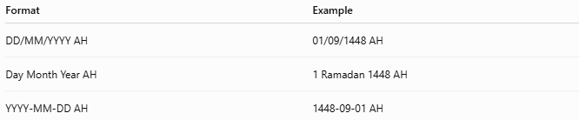
Format | Example
DD/MM/YYYY AH | 01/09/1448 AH
Day Month Year AH | 1 Ramadan 1448 AH
YYYY-MM-DD AH | 1448-09-01 AH

Major Islamic Events
# Source: AI Source: Provided by: [Data Path: Persons Table -> ID Column: 1, Name_En Column: Motasem Essam] -> From: [ChatGPT] on [7/17/2026]
The Hijri Calendar determines the dates of:
- Ramadan
- Eid al-Fitr
- Hajj
- Eid al-Adha
- Islamic New Year (1 Muharram)
Since the calendar is lunar, these events occur about 11 days earlier each Gregorian year.

Applications
# Source: AI Source: Provided by: [Data Path: Persons Table -> ID Column: 1, Name_En Column: Motasem Essam] -> From: [ChatGPT] on [7/17/2026]
The Islamic Calendar is used in:
- Religious observances
- Mosques
- Islamic education
- Religious publications
- Islamic legal matters
- Cultural events
Some countries also use it officially alongside the Gregorian Calendar.

Advantages
# Source: AI Source: Provided by: [Data Path: Persons Table -> ID Column: 1, Name_En Column: Motasem Essam] -> From: [ChatGPT] on [7/17/2026]
The Hijri Calendar:
- Closely follows the Moon's phases.
- Is central to Islamic religious life.
- Preserves important historical and religious traditions.
- Provides a consistent framework for Islamic observances.

Limitations
# Source: AI Source: Provided by: [Data Path: Persons Table -> ID Column: 1, Name_En Column: Motasem Essam] -> From: [ChatGPT] on [7/17/2026]
The Hijri Calendar:
- Is not synchronized with the seasons.
- Requires moon sighting or accepted astronomical calculations to determine the start of months.
- Is less commonly used for international civil and business purposes.

Comparison with the Gregorian Calendar
# Source: AI Source: Provided by: [Data Path: Persons Table -> ID Column: 1, Name_En Column: Motasem Essam] -> From: [ChatGPT] on [7/17/2026]
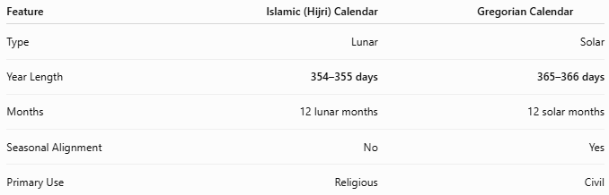
Feature | Islamic (Hijri) Calendar | Gregorian Calendar
Type | Lunar | Solar
Year Length | 354–355 days | 365–366 days
Months | 12 lunar months | 12 solar months
Seasonal Alignment | No | Yes
Primary Use | Religious | Civil

Common Mistakes
# Source: AI Source: Provided by: [Data Path: Persons Table -> ID Column: 1, Name_En Column: Motasem Essam] -> From: [ChatGPT] on [7/17/2026]
- Assuming Hijri months always have exactly 30 days.
- Expecting Islamic holidays to occur on the same Gregorian date each year.
- Confusing AH (Anno Hegirae) with CE (Common Era).
- Forgetting that different communities may begin a month on different days depending on moon sighting practices.

Key Points
# Source: AI Source: Provided by: [Data Path: Persons Table -> ID Column: 1, Name_En Column: Motasem Essam] -> From: [ChatGPT] on [7/17/2026]
- The Islamic (Hijri) Calendar is a lunar calendar.
- It begins with the Hijrah of Prophet Muhammad in 622 CE.
- It contains:
  - 12 lunar months
  - 354 or 355 days per year
- Islamic months follow the phases of the Moon.
- Major religious events such as Ramadan, Eid al-Fitr, Hajj, and Eid al-Adha are determined using this calendar.
- Because it is shorter than the solar year, its months rotate through all seasons over time.

Conclusion
# Source: AI Source: Provided by: [Data Path: Persons Table -> ID Column: 1, Name_En Column: Motasem Essam] -> From: [ChatGPT] on [7/17/2026]
The Islamic (Hijri) Calendar is a lunar calendar that plays a central role in the religious and cultural life of Muslims worldwide. Beginning with the Hijrah in 622 CE, it measures time through 12 lunar months, resulting in a year of 354 or 355 days. Unlike solar calendars, it is not tied to the seasons, causing Islamic months and festivals to shift gradually through the Gregorian year. Despite this, it remains the authoritative calendar for determining Islamic religious observances and preserving the historical chronology of Islam.

